judges certification
courses

seminar 1 –theory: the basics of judging
seminar 2 – practice: shadow judging florint europa cup

3rd – 10th April 2016
genoa, italy
florint judges

For 30 years Florint has been developing and fine-tuning a judging system that is both neutral, transparent and rigorous, just as competitions demand their judging system to be.

Over the years, Florint designed the 100-point system, a tool that allows judges to follow a system that looks at a competitor’s work through a completely new lens. This judging system was easy to use and transparent, yet fairly sophisticated. Since its launch the system was – and still is – constantly being improved upon. Candidate judges were required to follow some courses to get acquainted with the methodology, and thereafter were included in Florint’s list of official European floristry judges.

A few years ago however, Florint, together with Flornet, STOAS University and other industry partners, decided to further improve upon this system. What came out of this initiative and the two-year project that followed it, was the Judges Certification (‘JudgCert’) system: the new method Florint will henceforth recognize, replacing the old judges courses. This new system remains based upon the 100-points evaluating system, however, knowledge of which therefore remains vital to becoming a judge.

This new JudgCert system accredits judges only after a meticulous assessment to evaluate whether the candidate is sufficiently capable of performing professionally as a judge, in a national and international competition setting, by knowing how to analyse, evaluate and commentate in a professional and neutral way.

The European Judges Certification system is based upon the competence profile for a professional international judge. Its key objectives are:

- to enhance the reputation of (certified) international judges;
- to function as an indicator of experience, skill and professionalism;
- to provide a recognized international accreditation to European/international judges
- to encourage the development of knowledge and skills pertinent to professional judging
- to allow judges to demonstrate outstanding professionalism to peers and to potential prospects

We hope the system will elevate judging in floral design competitions as well as in schools/colleges to a higher level, will create more transparency regarding judging competences, and will provide a huge stimulus to the exchange of knowledge with regards to the craft of judging – throughout Europe as well as other parts of the world.

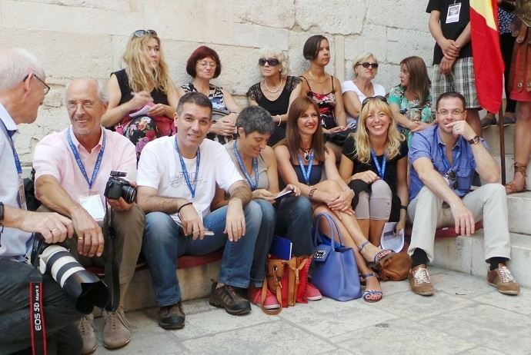
the judgcert
courses
seminar 1 –theory: the basics of judging

To be a judge nowadays, it is no longer sufficient just to know of the 100 point system. This international seminar will explain all the main elements of floral design judging, giving you the knowledge and firm base to be able to enter into a JudgCert national assessment.

Florint, together with STOAS university professors Jan van Doesburg and Erik van Heijst, will be organising 2 seminars.

Seminar 1
The first will take place from Monday 4th April-Wednesday 6th April after the successful seminar in Rotterdam in November 2015 and in Moscow in 2016.

The seminar will focus on how to prepare for the new JudgCert scheme, by showing you the essentials of the 100-point system, how to use the system, and looking at the three main qualities required to be a judge. These qualities will be tied in together with the 100-point system.

The course will run for three days and will be both practical and theoretical. You will go over the following topics:

- Information on the 100 point system
- Information on the applying portfolio
- Analysing flower arrangements
- Evaluating flower arrangements
- Commentating flower arrangements
- Using evaluation, analysis and commentating at the same time

The courses will be practical, with live flower arranging, group discussions, group sessions and more one-on-one problem solving.

At the end of the course you will receive the STOAS EFDA certificates and a Florint certificate stating you have attended this course. (These certificates are not official certificates and will not certify you as a JudgCert judge). The participants can use these certificates as part of the application portfolios in future JudgCert assessments, as proof of knowledge of the judging processes for floral competitions.

NB – FLORINT WILL NOT CONFIRM THE SEMINAR YET. PLEASE SEND YOUR FORM, BUT DO NOT PAY, RESERVE FLIGHTS OR HOTELS UNTIL WE CAN CONFIRM THIS SEMINAR ON THE 2ND MARCH.
course
programme:
seminar 1

day one

Monday, 4th April

9:00 - 12:30

General Information
- Welcome
- Introduction trainers and participants
- Short history of the National Certified Judge system
- Introduction National Certified Judge assessment
- Goal of this 3 day seminar
- Additional training
- Explanation of the application portfolio

12:30 - 13:30 - Lunch

13:30 - 17:00

Analysing
- Observing flower arrangements
- Introduction to the Gestallt laws and composition terminology
- Introduction to the analysing form
- Using the analysing form

17:00-18:00 – Dinner

18:00-21:00

Evaluating
- Quality aspects of judging
- Judging education arrangements using different evaluation systems

Conclusion of the first seminar day

day two

Tuesday, 5th April

09:00 - 12:30

Analysing and Evaluating
- analysing competition arrangements
- introduction Florint 100 points system
- using the Florint 100 points system in different competition situations
- discussion about the results

12:30 - 13:30 - Lunch

13:30 - 17:00

Questioning
- Structuring question rounds about application portfolio, coaching and the assessment
- Quality aspects of assignments

Conclusion of the second seminar day

day three

Wednesday, 6th April

9:00 - 12:30

Commentating
- Use of professional terminology in floral design
- Experiencing different commentating situations

12:30 - 13:30 - Lunch

13:30 - 17:00

Analysing, Evaluating and Commentating
- Analysing educational assignments
- Analysing education arrangements
- Evaluating education arrangements
- Commentating education arrangements

17:00 - 18:00 Conclusion of the third seminar day

- Handing out of European Floral Design Academy (EFDA) certificates by STOAS
- Handing out of Florint certificate by Toine Zwitserlood, JudgCert Expert Florint

NB – FLORINT WILL NOT CONFIRM THE SEMINAR YET. PLEASE SEND YOUR FORM, BUT DO NOT PAY, RESERVE FLIGHTS OR HOTELS UNTIL WE CAN CONFIRM THIS SEMINAR ON THE 2ND MARCH.

the judgcert
courses
seminar 2 –practice: shadow judging florint europa cup

Seminar 2
The second seminar will take place from Friday 8th April-Sunday 10th April and will build on the practice seminar that took place in Rotterdam, Moscow and on the previous days in Genoa.

This seminar is extremely unique as it will focus on the real issues and real judging at the most important and technical florist competition in the florist world: Europa Cup. The seminar will cover all the aspects of real judges and participants will be able to shadow judge together with the real judges of Europa Cup and the competitors. Too good to be true? Well you’ve read right!

The course will run for three days and will be both practical and theoretical. You will go over the following topics:

- Recap on the previous seminar
- Competition regulations
- Competition aspects
- Analysing several tasks of the Europa Cup
- How judges prepare
- Evaluating several tasks of the Europa Cup
- Being present at the feedback round of all competitors

At the end of the course you will receive the STOAS EFDA certificates and a Florint certificate stating you have attended this course. (These certificates are not official certificates and will not certify you as a JudgCert judge). The participants can use these certificates as part of the application portfolios in future JudgCert assessments, as proof of experience of the judging processes for floral competitions.

course
programme:
seminar 2

day one

Friday, 8th April

9:00 - 12:30

General Information
-welcome
-introduction trainers and participants
-short review seminar 1
-National Certified Judge seminar in an international setting
-goal of this 2 days seminar
-short introduction 2 days program
-competition regulations
-aspects of competition and examination situations

12:30 - 13:30 - Lunch

13:30 - 17:00

Analysing
- analysing competition tasks 1 and 2
- researching the potential of tasks 1 and 2
- preparing for judging
- preparing for shadow judging

17:15-18:15 – Dinner

18:15-21:15

Shadow judging
- analysing and evaluating 2 competition pieces (tasks 1 and 2)
- guided group discussion
- reflection on the group discussions

Conclusion of the first seminar day
day two

Saturday, 9th April

09:00 - 12:30

Analysing, Evaluating and commenting
-analysing and valuing 1 of the other competition pieces of task 1 or 2
-preparing the commentating
-commentating one of the competition pieces and explaining the marks
-feedback on the commentating and explaining

12:30 - 13:30 - Lunch

13:30 - 14:30

Ranking
- ranking competition pieces of task 3
- explanation of observing task sunday

14:30: Conclusion of the seminar day

- Handing out of European Floral Design Academy (EFDA) certificates by STOAS
Handing out of Florint certificate by Toine Zwisterlood, JudgCert Expert Florint
day three

Sunday, 10th April

11:00

Questioning
- Question round between seminar participants and members of the jury of the Europa Cup 2016

12:00

Observing
- Participants of seminar 2 observe the jury members giving feedback to the competitors

14:00

Reflecting
- Reflecting on the observers

14:30 Conclusion and Lunch

the teachers

Jan van Doesburg  Senior Teacher at Stoas Vilentum University of applied sciences and teacher’s education.  Manager European Floral Design Academy.  Master Florist.  Author:  Participant, judge and organizer national and international floral design competitions. | Erik van Heijst  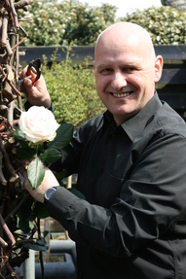  Teacher at Stoas Vilentum University of applied sciences and teacher’s education and manager of EFDA.  Erik is also an official examiner for the professional qualifications (Advanced) Dutch Flower Arrangements, All-Round Dutch Flower Arranger and the Dutch Master in Floral Design.  Master Florist.

Toine Zwitserlood  1981 – 2007 Association manager Dutch Florist Association.  1993 – 2013 General secretary / manager International Florist Organisation FLORINT  1995 – 2015 President Taskforce Competitions FLORINT  2011 – now Expert of the Judges Certification Program of FLORINT  2013 – now Certified Assessor of the Judges Certification Program | Marios Vallianos  Chairman for the Jury of:  2010 – Eurofleurs UK  2011 – Europa Cup Czech Republic  2012 – International Competition Belgium  2013 – Eurofleurs Croatia  2015 – World Cup Fleurop

rates

The Judgcert courses will take place in Genoa, Italy. The first seminar will be from the 4-6th April 2016, and the second seminar from the 8-10th April 2016.

The rates for the course are the following:

Seminar 1 (4-6th April 2016)

NB – FLORINT WILL NOT CONFIRM THE SEMINAR YET. PLEASE SEND YOUR FORM, BUT DO NOT PAY, RESERVE FLIGHTS OR HOTELS UNTIL WE CAN CONFIRM THIS SEMINAR ON THE 2ND MARCH.

Members, Corporate Members, and Flornet

For member florists of Florint’s national associations, Florint corporate members and Flornet schools the fee will be as follows:
1.100€

All others participants will pay the full fee:
1.400€

Minimum amount of participants: 15
Maximum amount of participants: 30

To see if you belong to a member association of Florint, please visit Florint’s members page by clicking on the following link.

To see if you belong to a Flornet school, please visit Flornet’s members page by clicking on the following link.

The prices cover the following costs of the course:
- Rooms
- Coffee breaks
- Lunches
- Course Material
- Teachers
- Flowers

Seminar 2 (8th- 10th April 2016)

Members, Corporate Members, and Flornet

For member florists of Florint’s national associations, Florint corporate members and Flornet schools the fee will be as follows:
1.750€

All others participants will pay the full fee:
2.100€

Maximum amount of participants: 21

To see if you belong to a member association of Florint, please visit Florint’s members page by clicking on the following link.

To see if you belong to a Flornet school, please visit Flornet’s members page by clicking on the following link.

The prices cover the following costs of the course:
- Rooms
- Coffee breaks
- Lunches
- Course Material
- Teachers
- Flowers
- Entrance for Europa Cup for all of the events (excluding Reception and award ceremony, but including Sunday)

Seminar 1 + 2 (saving price)

Members, Corporate Members, and Flornet

For member florists of Florint’s national associations, Florint corporate members and Flornet schools the fee will be as follows:
2.700€

All others participants will pay the full fee:
3.250€

NB – FLORINT WILL NOT CONFIRM THE SEMINAR YET. PLEASE SEND YOUR FORM, BUT DO NOT PAY, RESERVE FLIGHTS OR HOTELS UNTIL WE CAN CONFIRM THIS SEMINAR ON THE 2ND MARCH.

venue, hotel
and rooms

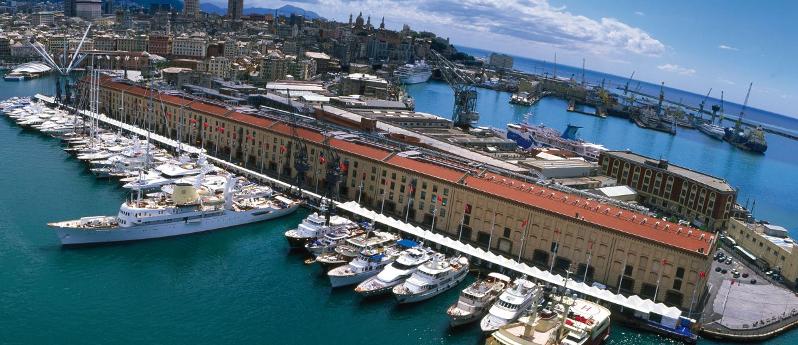

The Judgcert course will take place at the Magazzini del Cotonne, the same venue as the Europa Cup. The address is the following:

Magazzini del Cotonne
16128 Genova
Italy

How to get there:

The Magazzini del Cotonne is ideally located near Genova’s main attractions.

For more information on how to get there from Genoa airport, stations or by car, please visit their website by clicking on the following link.

Rooms

Florint has managed to get special prices for guests that includes free Wi-Fi and breakfast at the 3 hotels: NH Collection, Best Western Porto Antico, and Best Western City, the Best Western Metropoli.

NH Collection (closest to the venue)
Prices (estimate): 140,00€/1 room per night

Best Western Porto Antico (1km from the venue, but also competitors room)
Prices (estimate): 115,00€/1 room per night

Best Western Metropoli (15min walk from the venue in a more central area of Genoa)
Prices (estimate): 115,00€/1 room per night

Best Western City (15min walk from the venue in a more central area of Genoa)
Prices (estimate): 120,00€/1 room per night
registration

In order to register you will need to fill out a registration form, which you will be able to find at the following link.

NB – FLORINT WILL NOT CONFIRM THE SEMINAR 1 YET. PLEASE SEND YOUR FORM, BUT DO NOT PAY, RESERVE FLIGHTS OR HOTELS UNTIL WE CAN CONFIRM THIS SEMINAR ON THE 2ND MARCH.

Please click here for the registration form

Once you have filled in the registration form, please send us the following information:

- Filled out registration form
- Proof of payment for the course (bank statement/payment statement)

Please send this by email to Dianne Ramakers on the email indicated in the registration form.

Please remember, registration closes on the 1st March 2016 or when the course is full.

